Week 10 – Jira Assignment 6

Screenshot # 1 – Configure your sprint board, add at least 2 new columns and 3 new status’s that make sense for your project.

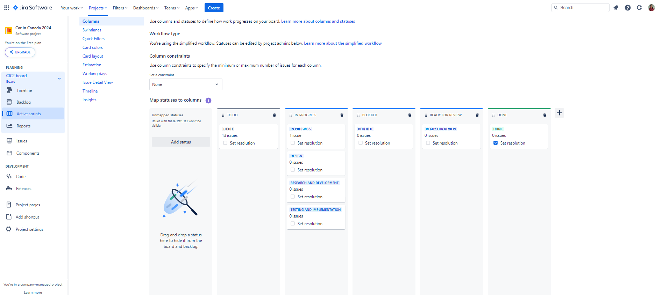

Screenshot # 2 – Start the sprint you created last class. Make sure to take your screenshot before you click start the second time.

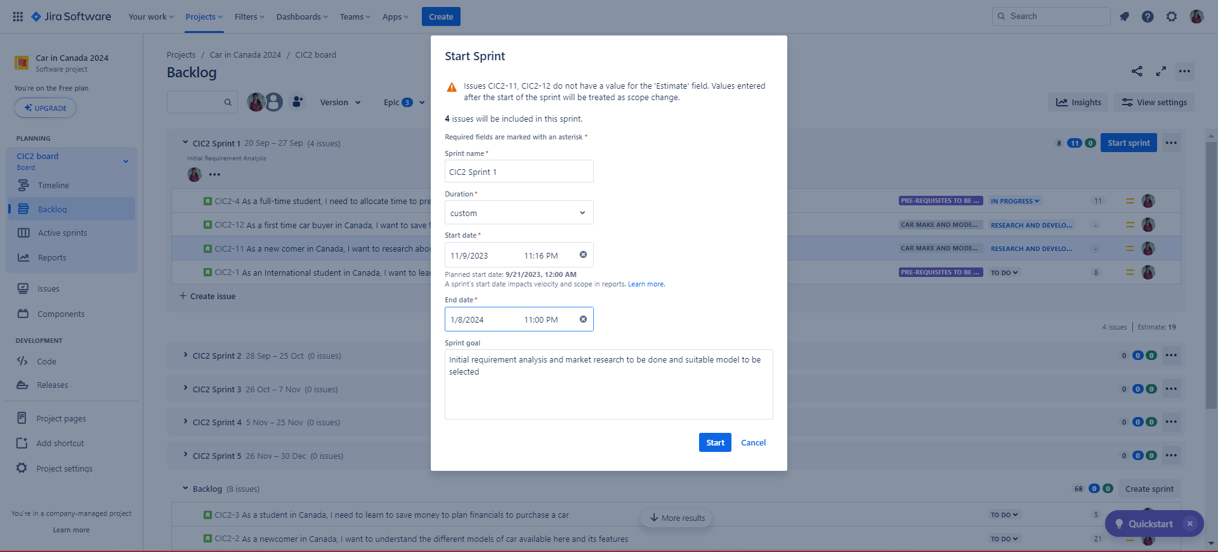

Screenshot # 3 – Move stories / sub tasks across your board by dragging. Try to do this as realistically as possible.

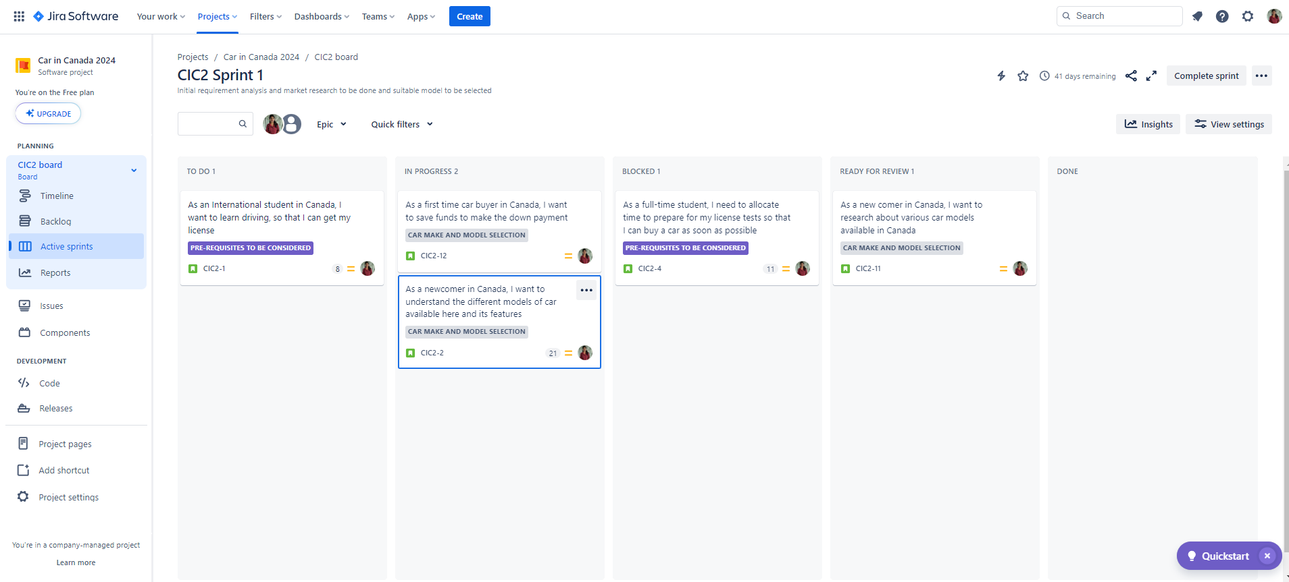

Screenshot # 4 – Create a bug story for your sprint, move it to the top of your backlog or into your sprint in the blocked section.

